Shariatpur **Go Back**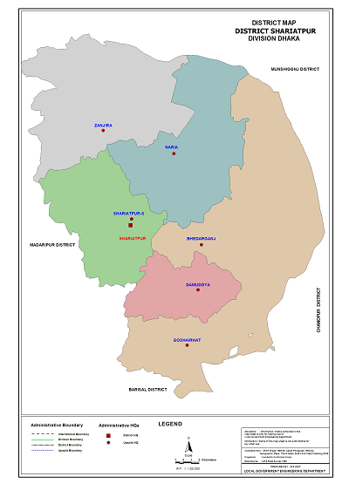

**Area:** 1174.05 Square Kilometres.

**Population:** 11,55,824.

**Geo Position:** 23˚01’ to 23˚27’ North latitudes and 90˚13’ to 90˚36’ east longitude.

**Number of Municipalties:** 05.

**Number of Sub-districts:** 06.

**Number of Villages :** 1,254.

**Number of Union:** 65.

**Establishing Year:** 1984.

**Tourist Spot:** Home of Hazi Shariatullah, Chikondi Munshef Court, Beparipara Jame Hat Mosque, Fatehjongpur Fort, Haturia Royal Palace,

Kartikpur Royal Palace, Shakhipur Ananda Bazar Dam, Kedarbari, Sureshwar Darbar Sharif, M.A. Reza College, Bhedargonj Upazeela Premise, Mahishar Lake, Dargahbari Lake, Dhanukar Monosha Bari, Tinu Tagore House Kali Mondir, Kirtinasha Fort, Vojeswarer Paul Bari, Padma River’s Islands, Circuit House, Pachani Paler Bari, Agaroani Paler Bari, Kodal Pur Darber Sharif etc.

**Others:**Bears many incidents related to the historical Forayezi Revolt..